<https://kissflow.com/project/why-projects-fail/>

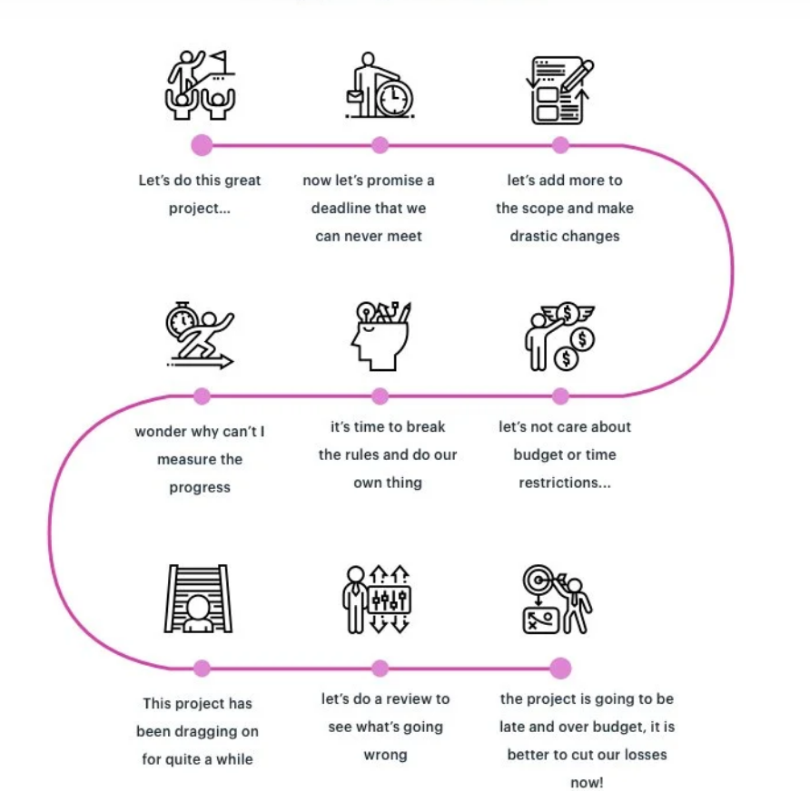

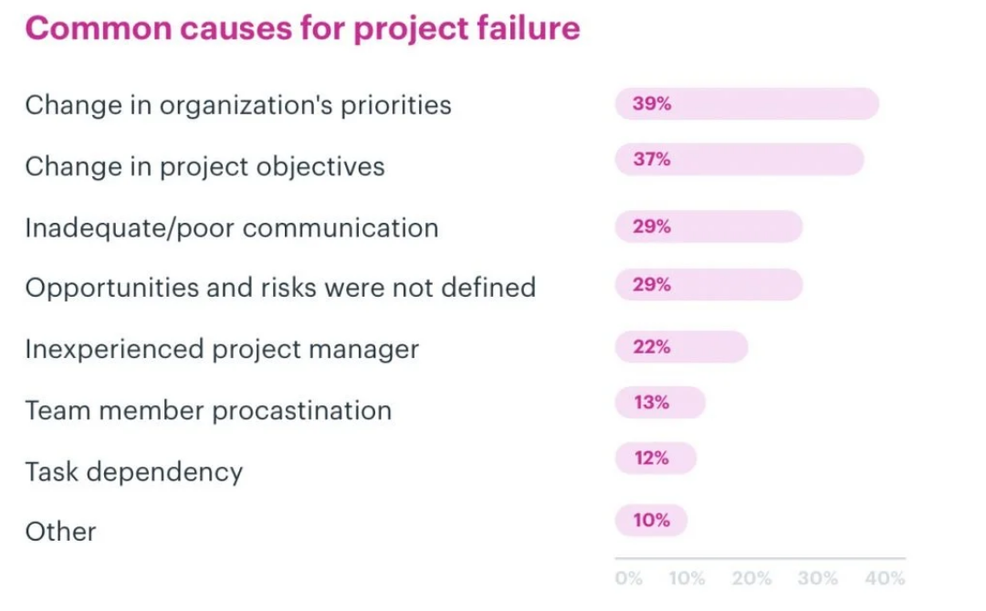





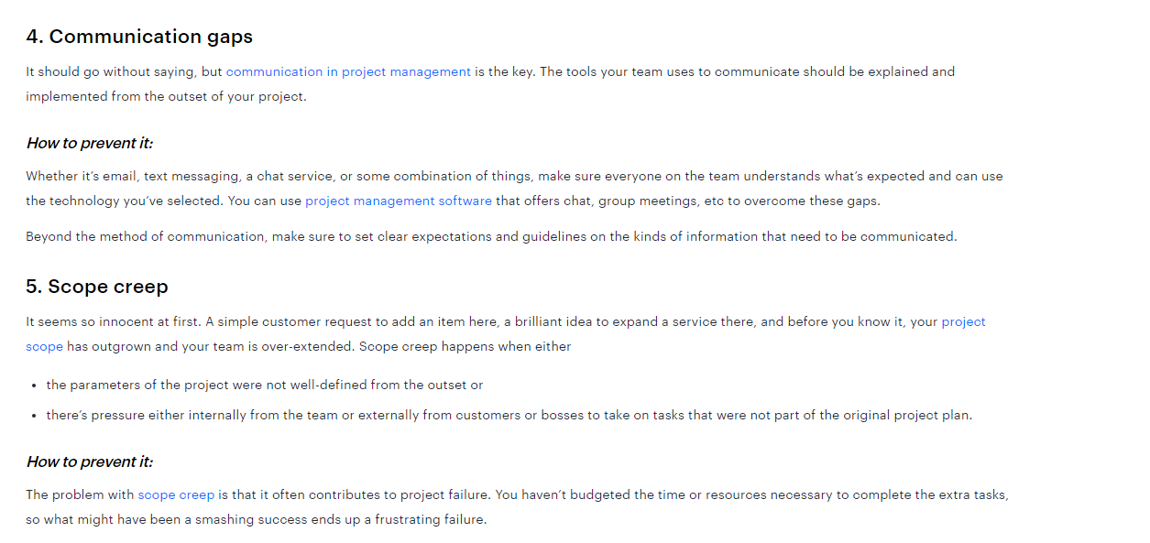



Flexible Querying and Visualization allows users to interactively explore and analyze the time series data through custom queries and dynamic visualization tools, providing adaptability in data exploration.

Limited Scalability

Limited Scalability refers to the inability of the current system to handle increasing data volumes or user demands without significant architectural changes or performance degradation.

As c suite executive, give an analogy using restaurant businesses of Hbase limitation on time series and maket data

Imagine you are running a large, bustling restaurant chain, and HBase is like the kitchen's ordering and inventory management system. Here’s how HBase’s limitations could impact operations:

1. **Write Latency**: This is like when chefs take longer to note down new stock as it arrives. It ensures accuracy, but during a rush, delays in updating can lead to serving errors or missed opportunities to prepare dishes quickly.
2. **Complexity in Time-based Queries**: Using HBase for time-based data is akin to trying to track which ingredients were used at which hour without an organized system. If a health inspector asks for a report on ingredient usage timing, gathering this information from a disorganized record could be slow and cumbersome.
3. **Limited Aggregation Support**: Imagine needing to quickly calculate the total sales of each dish at the end of the night, but the system doesn't automatically tally up these numbers. Instead, staff must manually sum these figures, which can be time-consuming and prone to errors.
4. **Data Model Constraints**: If the system is set up to categorize inventory or orders in a non-intuitive way—say, by supplier code rather than by type of food or dish—it can make finding and using information difficult, especially during busy periods.
5. **Consistency Issues**: Eventual consistency in HBase is like updates to the menu or ingredient list that take time to reflect across all sections of the kitchen. This might lead to situations where cooks are not aware of changes, potentially leading to errors in meal preparation.
6. **Maintenance and Scalability**: As your restaurant chain grows, keeping the system performing well and scaling with more data (more menu items, more orders) requires continuous tuning and adjustments. This is similar to constantly needing to reorganize a growing kitchen to keep it running efficiently.
7. **No Support for Complex Transactions**: If an order requires updates across multiple data points (like changing an order while also updating inventory), HBase's lack of multi-data transaction support would require these to be processed separately, complicating operations during high-pressure service times.
8. **Read Performance Variability**: This would be like if ingredients stored in different parts of the kitchen vary in how quickly they can be accessed. Some items might be immediately on hand while others take longer to retrieve from storage, affecting the speed and consistency of meal preparation.

This restaurant analogy highlights how HBase might face challenges in efficiently managing and utilizing time series and market data in environments where speed, consistency, and accuracy are crucial.

As c suite executive, give an analogy using trading business of Hbase limitation on time series and maket data

Imagine you are managing a high-frequency trading firm, and HBase is like the data management system used for storing and accessing trade and market data. Here's how HBase's limitations could impact your trading operations:

1. **Write Latency**: This is akin to a trader who records transactions manually in a ledger. While meticulous, the process is slow. In a fast-paced trading environment where milliseconds can mean significant profit differences, delayed data recording can lead to missed opportunities and outdated information impacting trading decisions.
2. **Complexity in Time-based Queries**: Using HBase for time-based data is like trying to analyze trades by specific time frames using a ledger that's organized alphabetically by stock symbol rather than chronologically. Finding all trades within a specific minute can be cumbersome and slow, which is impractical when split-second decisions need to be made based on the latest data trends.
3. **Limited Aggregation Support**: Imagine needing to quickly calculate total trading volumes or average prices but having to manually add up each trade from a printout because the system doesn't automatically perform these aggregations. This manual process is error-prone and inefficient, hindering real-time strategic decision-making.
4. **Data Model Constraints**: If HBase organizes data in a non-intuitive manner (like sorting by internal transaction IDs rather than market trends or times), it can make accessing relevant trading information during peak times slow and frustrating, similar to looking for a needle in a haystack.
5. **Consistency Issues**: HBase's eventual consistency model in a trading context means that the latest trading data might not immediately be available across all systems. This would be like traders having slightly different versions of stock prices, leading to potential discrepancies in trading decisions.
6. **Maintenance and Scalability**: As trading volumes grow, maintaining and scaling an HBase system to ensure continuous, efficient performance becomes a complex task. This is similar to continually needing to optimize a trading algorithm or expand trading infrastructure to handle increased activity, requiring significant ongoing investment in both time and resources.
7. **No Support for Complex Transactions**: In trading, simultaneous updates to multiple records (like buying one stock while selling another) are crucial. HBase’s lack of support for complex, multi-record transactions might force these to be processed sequentially, increasing the time for each transaction and risking price movements in the interim.
8. **Read Performance Variability**: If accessing historical trading data depends on where it is stored, with some data on fast-access drives and other data on slower storage, retrieving this data can be inconsistently slow. This is like traders having different access speeds to crucial market information, potentially leading to unequal trading opportunities.

This trading firm analogy illustrates how HBase might struggle to meet the demands of high-frequency trading where speed, accuracy, and real-time data access are critical.

HBase isn't necessarily outdated, but it is designed with specific use cases in mind, and its suitability for time series and market data management depends on the specific requirements of the task.

HBase isn't necessarily outdated, but it is designed with specific use cases in mind, and its suitability for time series and market data management depends on the specific requirements of the task.

**Here's what to consider regarding HBase's current relevance and suitability:**

1. **Scalability and Big Data**: HBase is highly scalable and excels in environments where massive datasets are involved. It's based on Google’s Bigtable design and integrates well with other Hadoop ecosystem components for processing large-scale data. This makes it a good choice for applications where horizontal scalability and the ability to handle enormous amounts of data are critical.
2. **Real-time Access**: HBase provides real-time read/write access to its data, which is a significant advantage for applications needing immediate data retrieval but not necessarily requiring the high throughput of transactions per second that other systems might offer.
3. **Flexibility in Data Model**: The column-oriented data model of HBase is flexible and allows for efficient storage and retrieval of sparse datasets, which are common in big data scenarios.

**However, for time series and market data, here are some considerations:**

* **Write and Read Latency**: HBase may not be the best choice if low latency for both read and write operations is required. Time series databases like InfluxDB or TimescaleDB are optimized for this kind of operation, offering better performance for time series data.
* **Built-in Time Series Support**: Unlike specialized time series databases, HBase does not have built-in support for time-oriented functions like downsampling, rolling windows, and time-based aggregation, which are essential for time series analysis.
* **Complexity and Maintenance**: HBase requires careful configuration and maintenance, particularly as the system scales. The complexity of managing an HBase environment might be a drawback for organizations without the necessary expertise.

Explain the importance of no-code to low- code software to non-technical manager

No-code and low-code software platforms are powerful tools that greatly simplify the process of building and deploying software applications, making them particularly valuable for non-technical managers. Here's why they are important:

1. **Empowering Non-technical Users**: No-code and low-code platforms enable non-technical managers to create or adjust applications without deep programming knowledge. This empowerment means you can directly translate business ideas into functional applications without waiting for IT department schedules.
2. **Speed of Development**: These platforms significantly reduce the time it takes to develop applications. What might normally take weeks or months with traditional development can often be accomplished in days or even hours. This speed enables businesses to respond more rapidly to market changes or operational needs.
3. **Cost Efficiency**: By reducing the dependency on highly skilled software developers for every project, no-code and low-code platforms can lower the cost of development. They help in allocating resources more efficiently across the organization.
4. **Fostering Innovation**: When non-technical team members are able to experiment and develop solutions on their own, it opens up opportunities for innovation at every level of the organization. Managers can test ideas and refine processes without significant upfront investment in development resources.
5. **Bridging the IT-Business Gap**: These platforms help align business and IT departments by allowing non-technical stakeholders to be more actively involved in the application development process. This involvement leads to better outcomes because applications are more likely to meet the actual needs of the business.
6. **Improved Agility**: No-code and low-code platforms contribute to organizational agility by allowing businesses to adapt their tools and processes quickly as objectives or external conditions change. This agility is critical in maintaining competitiveness in fast-paced industries.
7. **Risk Mitigation**: By enabling faster and more frequent iterations, these platforms allow organizations to test and modify applications with minimal risk. Changes can be made and tested in real-time, reducing the likelihood of costly errors or the need to roll back large-scale issues after deployment.

In summary, no-code and low-code platforms are not just about making it easier to build applications; they are about transforming the way businesses innovate, adapt, and compete. They provide a pathway for managers at all levels to contribute directly to digital transformation efforts, enhancing both individual and organizational capabilities.

As c-suite executive, give an analogy of low-code no-code software to non-technical manager

ChatGPT

Memory updated

Imagine you’re a chef running a large restaurant kitchen, and low-code/no-code software platforms are like using a set of pre-prepared ingredients and semi-cooked meals. Here's how this analogy breaks down:

1. **Empowering Non-technical Users**: Just as pre-prepared ingredients allow someone with basic cooking skills to assemble dishes without needing the expertise of a trained chef, low-code/no-code platforms let non-technical managers build and deploy applications without deep programming skills.
2. **Speed of Development**: Using pre-prepared ingredients speeds up meal preparation significantly, just as low-code/no-code tools speed up the development process. What might take hours in traditional cooking—or coding—can be achieved in minutes.
3. **Cost Efficiency**: Just like it's cheaper to buy certain pre-made items than to hire a gourmet chef to make them from scratch, using low-code/no-code platforms can be more cost-effective than hiring a team of developers for every project.
4. **Fostering Innovation**: With access to a variety of ingredients that can be mixed and matched creatively, chefs can experiment with new dishes easily. Similarly, low-code/no-code platforms allow managers to experiment with new features and workflows, encouraging innovation within the business.
5. **Bridging the IT-Business Gap**: In a kitchen, if the staff can prepare dishes themselves using pre-prepared ingredients, they don’t need to rely on the head chef for everything. Similarly, low-code/no-code platforms reduce reliance on IT departments, as business managers can develop applications that meet their direct needs.
6. **Improved Agility**: Just as a kitchen using pre-prepared ingredients can quickly change the menu to suit customer preferences or ingredient availability, businesses using low-code/no-code platforms can quickly adapt their applications to meet changing business needs.
7. **Risk Mitigation**: In cooking, using pre-prepared ingredients reduces the risk of a dish going wrong due to a complex process. Similarly, low-code/no-code platforms reduce the risk of errors in software development, as the complex coding is largely handled by the platform.

This analogy shows how low-code/no-code platforms transform the approach to software development, making it more accessible, efficient, and adaptable for non-technical managers, much like how pre-prepared ingredients transform cooking in a busy restaurant.

What are the common problems for on prem market data platforms

ChatGPT

On-premises market data platforms, while offering control and customization, face several common challenges that can impact their efficiency and effectiveness. Here are some of the key issues:

1. **High Costs**: On-premises solutions typically involve significant upfront costs for hardware, infrastructure, and software licenses. Additionally, ongoing expenses related to maintenance, upgrades, and staffing can be substantial.
2. **Scalability Issues**: Scaling an on-premises platform to handle increased data volumes or additional computational needs often requires physical hardware upgrades or additional servers, which can be costly and time-consuming.
3. **Maintenance and Upgrades**: Keeping an on-premises system up-to-date with the latest security patches and software updates requires dedicated IT staff and can lead to downtime. Regular maintenance is crucial to ensure the platform remains reliable and secure.
4. **Disaster Recovery and Business Continuity**: On-premises systems typically require a substantial investment in disaster recovery solutions to safeguard data. This might include data backup, redundant systems, and other infrastructure, which can be expensive to implement and maintain.
5. **Data Security and Compliance**: While on-premises solutions provide control over security, the responsibility to secure access, protect against breaches, and comply with regulations lies entirely with the organization. This can be a significant burden, requiring expert staff and continuous oversight.
6. **Integration Challenges**: Integrating on-premises market data platforms with other systems (both on-premises and cloud) can be complex. This often involves extensive custom development work to ensure compatibility and maintain data integrity across systems.
7. **Speed to Market**: Deploying and configuring on-premises solutions can take much longer compared to cloud solutions, potentially delaying time-sensitive projects and the ability to react quickly to market opportunities or changes.
8. **Technical Debt**: Maintaining legacy systems that are often part of on-premises solutions can lead to accumulating technical debt, where outdated technology hinders innovation and efficiency.
9. **Resource Intensity**: Managing an on-premises infrastructure requires significant IT resources, from system administrators to security experts, which can divert focus from core business activities.
10. **Physical Space Requirements**: On-premises data centers require physical space, which can be a limitation for organizations with limited office space or those located in urban areas where space comes at a premium.

Common reasons for market data platforms initiative to fail

Market data platform initiatives can fail for various reasons, many of which stem from technical challenges, organizational dynamics, and strategic misalignments. Here are some common reasons these initiatives may not succeed:

1. **Inadequate Planning and Strategy**: Without a clear strategy and well-defined objectives, market data initiatives can lack direction and focus. This can lead to misaligned resources, conflicting priorities, and ultimately, project failure.
2. **Lack of Stakeholder Buy-In**: If key stakeholders are not on board or do not understand the value of the initiative, it can be difficult to secure the necessary support and resources. Resistance from users accustomed to old systems can also hinder adoption and success.
3. **Insufficient Budget and Resources**: Implementing a new market data platform often requires significant investment in both technology and skilled personnel. Underestimating these costs can lead to budget overruns, cut corners, and incomplete implementations.
4. **Technical Complexity and Integration Challenges**: Integrating new market data platforms with existing IT infrastructure can be complex and problematic. Technical issues, such as data migration errors, incompatible systems, and poor data integration, can derail the project.
5. **Data Quality Issues**: If the data feeding into the platform is of poor quality, incomplete, or not properly cleaned and validated, the output will be unreliable. Poor data quality undermines user trust and the platform's credibility.
6. **Failure to Manage Change**: Change management is critical when introducing new technologies. Without adequate training, communication, and support, users may struggle to adapt to the new platform, leading to low adoption rates and failure to achieve expected benefits.
7. **Scalability and Performance Shortfalls**: If the platform cannot scale effectively to handle increasing volumes of data or if it performs poorly, it will not meet the needs of its users. Performance issues can be particularly damaging if they impact critical decision-making processes.
8. **Regulatory and Compliance Issues**: Market data platforms must comply with relevant regulations, which can change frequently. Failure to comply can lead to legal penalties and damage to the organization’s reputation.
9. **Lack of Continual Improvement and Support**: Technology and business needs evolve, and without a plan for ongoing updates, maintenance, and support, a platform can quickly become obsolete. Continual improvement is essential for keeping the platform relevant and effective.
10. **Ineffective Project Management**: Poor project management can lead to scope creep, missed deadlines, and miscommunication. Effective leadership and project management practices are essential to keep the project on track and ensure alignment with business goals.

Metrics and kpis to measure if current market data platform is bad or good

When evaluating the performance and effectiveness of a market data platform, certain metrics and KPIs (Key Performance Indicators) are crucial to assess whether the platform is meeting the organization’s needs. Here are some important metrics and KPIs to consider:

1. **Data Accuracy and Integrity**:
   * **Error Rate**: The frequency of inaccuracies or errors in the data provided.
   * **Data Completeness**: Percentage of complete datasets without missing values.
2. **Performance and Reliability**:
   * **Latency**: The time it takes for data to be captured, processed, and made available to users.
   * **System Uptime/Availability**: Percentage of time the platform is operational without any disruptions.
   * **Query Response Time**: How long it takes for the system to respond to user queries.
3. **User Satisfaction and Engagement**:
   * **User Satisfaction Score**: Feedback scores from users regarding their satisfaction with the platform.
   * **Active Users**: Number of users who actively engage with the platform on a daily, weekly, or monthly basis.
   * **Adoption Rate**: The rate at which new users start using the platform and existing users continue to use it.
4. **Cost Effectiveness**:
   * **Cost per Query**: The average cost associated with processing each query.
   * **Return on Investment (ROI)**: The financial return generated by the platform compared to the investment made.
   * **Total Cost of Ownership (TCO)**: All costs associated with the platform, including acquisition, operation, support, and maintenance.
5. **Scalability**:
   * **Data Volume Growth**: Ability of the platform to handle increased data volumes without degradation in performance.
   * **Scalability Costs**: Costs involved in scaling the platform to handle more data or more users.
6. **Compliance and Security**:
   * **Compliance Violations**: Number of times the platform fails to meet regulatory requirements.
   * **Security Incidents**: Frequency and severity of security breaches or data leaks.
7. **Innovation and Flexibility**:
   * **Time to Market for New Features**: The speed with which new features can be developed and deployed on the platform.
   * **Flexibility Score**: How easily the platform can be adapted to new requirements or integrated with other systems.
8. **Operational Efficiency**:
   * **Maintenance Downtime**: Time spent on maintenance activities that result in downtime or reduced functionality.
   * **Incident Resolution Time**: How quickly technical issues are resolved.

These metrics provide a comprehensive overview of the performance, effectiveness, and efficiency of a market data platform. Regularly tracking these KPIs can help identify areas for improvement, ensure the platform aligns with business goals, and ultimately determine if the platform is good or needs enhancement or replacement.

